**Dial Deal**

Add the names of the group members here.

1. ABHISHEK SHARMA. ( 1000117797 )
2. LOVEPREET SINGH. ( 1000117287)
3. ABHISHEK CHOUDHARY. (1000118874)
4. PRABHKIRAT SINGH. (1000116211)
5. ARSHDEEP SINGH . (1000117912)

Table of Contents

1 Introduction 3

1.1 Scope 3

1.2 Project Timeine 3

2 Project Design 4

2.1 Software Design 4

2.1.1 Class Diagram 4

2.1.2 Sequence Diagram : Add the name of the user story here 4

2.2 User Interface Design 4

2.2.1 Persona 4

2.2.2 Scenario 4

2.2.3 Storyboard 5

2.2.4 Wireframes 5

3 Use of Agile 5

3.1 Adapting AGILE in developing the project 5

3.2 Managing the Trello board 5

3.2.1 Daily Standups 5

3.2.2 Sprint planning and Sprint Review meetings 5

4 Version Controlling 6

5 Contributions 6

References 6

# Introduction

## Scope

If you are referring to "Dialdeal," it is an Indian-based company that provides local search services through its website and mobile app. Dialdeal allows users to search for various businesses and services in their local area, including restaurants, hotels, doctors, plumbers, and more.

The scope of dial's services includes:

1. Local Business Search: Users can search for specific businesses or services in their locality using keywords, categories, or location-based searches.

2. Contact Information: Dialdeal provides contact details such as phone numbers, addresses, and website links for the businesses listed in their directory.

3. User Reviews and Ratings: Users can read and contribute reviews and ratings for businesses, helping others make informed decisions.

4. Advertising and Promotion: Dialdeal offers advertising and promotional services for businesses to increase their visibility and reach to potential customers.

5. Online Booking: Some businesses listed on Dialdeal allow users to book appointments or services directly through the platform.

## Project Timeine

A simple timeline throughout your sprint reviews: it could be a table, a list or a gannt chart.

|  |  |
| --- | --- |
| Week 1 | Group dicussions ,  Standups |
| Week 2 & 3 | Decision making  project topic (selection ) |
| Week 3 | Designing structure of business |
| Week 4 & 5 | Ux & ui designs |
| Week 5 & 6 | Wireframes , finalizing u1 design ,coding , |
| Week 7,8 | Fixing coding and eliminating errors |

# Project Design

Discuss briefly what you were trying to achieve with these designs and reflect your experience how it helped, or not. There is no write or wrong answer here. A paragrapgh or two would be sufficient but make sure that it’s your own reflection as a team.

## Software Design

### Class Diagram

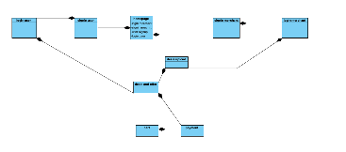

### Sequence Diagram : Add the name of the user story here

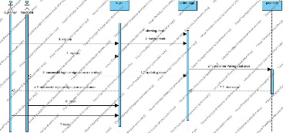

## User Interface Design

Persona: Barry

Name: Barry

Age: 32

Occupation: Marketing Manager

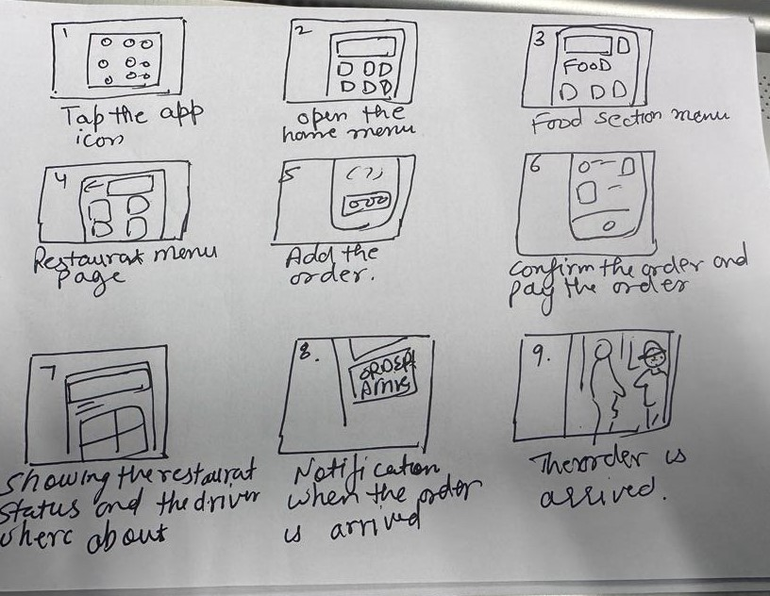

Background: Barry is a busy professional who works long hours and often needs to juggle multiple responsibilities. He relies on his smartphone to stay connected with colleagues, friends, and family and to manage his personal and professional life. Barry is a tech-savvy individual who is comfortable using online services and apps.

Goals: Barry wants to save time and effort when searching for local businesses and services. He wants to quickly find reliable and trustworthy vendors for a variety of needs, including restaurants, salons, and medical services. Barry values convenience and efficiency and wants to be able to access information on-the-go.

Pain Points: Barry finds it difficult to navigate through the overwhelming amount of information available online. He often feels uncertain about the quality and reliability of online reviews and worries about being scammed or receiving poor service. Barry also finds it frustrating when businesses don't have updated contact information or don't respond promptly to inquiries.

How Dial Deal can help: Dial Deal can provide Barry with a comprehensive and reliable directory of local businesses and services, complete with ratings and reviews from other users. The platform's easy-to-use search and filter options can help him quickly find what he's looking for. The ability to book appointments and make reservations directly through the platform can save him time and effort. Barry can rely on Dial Deal to provide up-to-date contact information and prompt customer service support if he has any questions or concerns.

By using Dial Deal, Barry can overcome his pain points and find a convenient solution to his local business search needs. The platform's user-friendly interface and reliable information can help Barry make confident choices and streamline his search process, ultimately saving him time and ensuring he receives quality services from trusted vendors.

### Scenario

Scenario 1: Ordering Food Delivery A user named Emma is in the mood for some Indian food and decides to order food delivery using Just Dial. She opens the Just Dial app and clicks on the "Food Delivery" category. She selects the type of cuisine she wants and enters her location. Just Dial shows her a list of restaurants that deliver to her area. She selects a restaurant that has good ratings and reviews and clicks on the menu to place her order. She selects the dishes she wants and adds them to her cart. She checks out and pays for her order using the app. She receives a confirmation message with the estimated delivery time. Emma is happy that she was able to order food delivery quickly and easily, without having to search multiple websites or apps.

Scenario 2: Finding a nearby restaurant. Anjali is meeting a friend for lunch in a part of town that she's not familiar with. She pulls out her smartphone and opens the Just Dial app. She clicks on the "Restaurants" category and enters the name of the neighbourhood where she'll be meeting her friend. She sees a list of restaurants with ratings and reviews from other users, as well as their contact information, location, and hours. She clicks on one restaurant that looks promising and sees more information, such as photos of the food and menu items. She decides to make a reservation and clicks the "Book Now" button. She chooses the number of guests, date, and time and confirms the reservation. She sees a confirmation message and adds the reservation to her calendar. Anjali feels relieved that she was able to quickly and easily find a good restaurant and make a reservation, without having to spend a lot of time searching and calling around.

### Storyboard

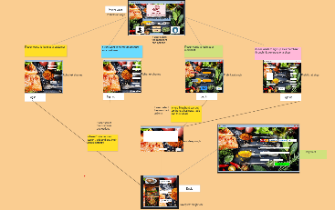

### Wireframes

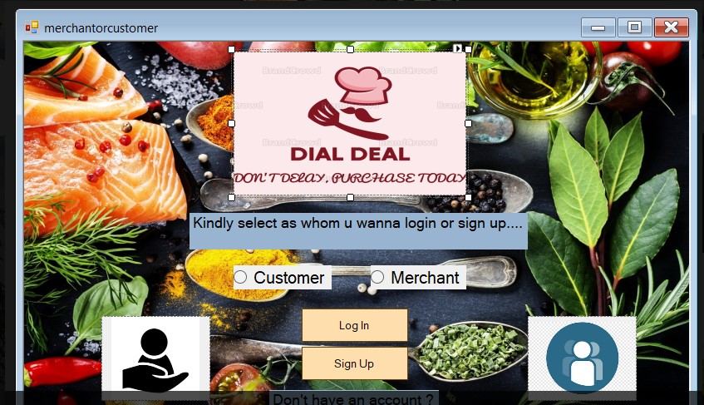

As a business owner and a user there will be homepage of the system I can check and then I can select an option like merchant or user by which I can enter the new market of offers and deals where post deals and grab deals

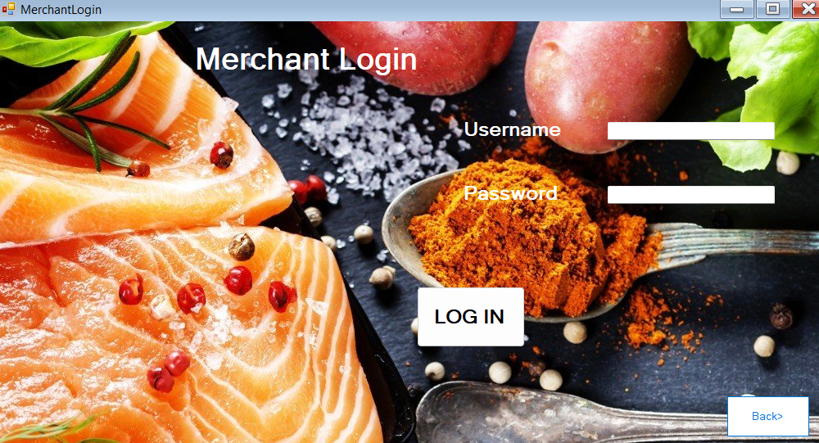

As a business owner, I can login my merchant id to enter the promoters page where I can upload my favourite deals which will be beneficial increase the walk in of customers . there is also an option for new merchants to get registered on sign up option on home page

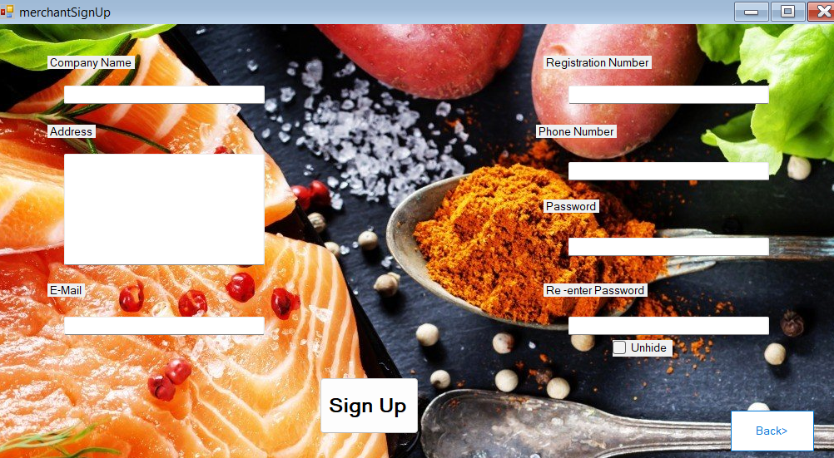

Sign up page for merchants

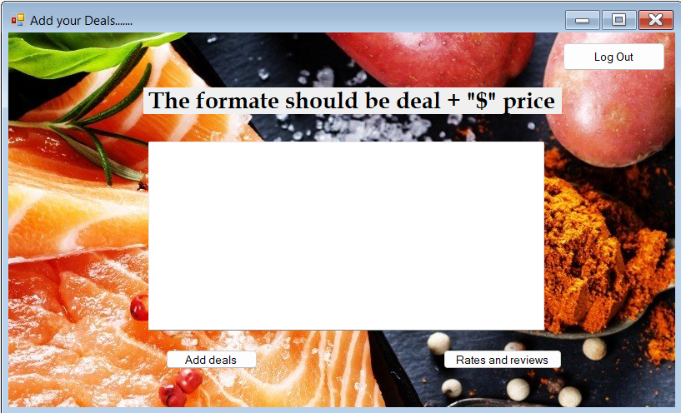

If I am already user of add system and I have merchant login id then I can see this page to upload my offer for business expansion in sales

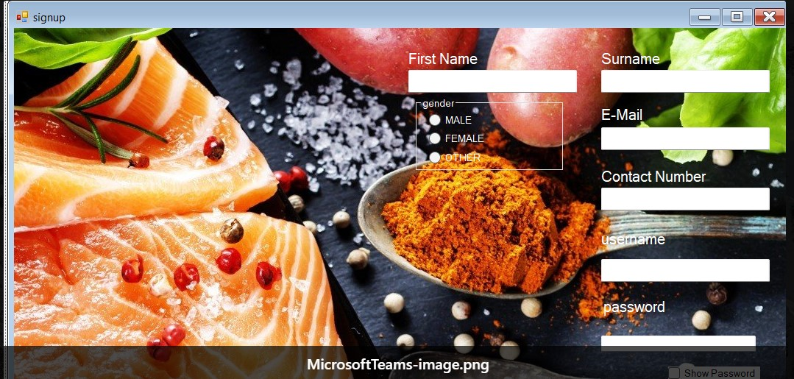

As new one to this system I have option for registering myself basic information and a get an account.



As an old member of this dialdeal sysytem I donot require to do regestraion process I can directly go to lgin page and jump to deals page and select on or more with cheap prices also can add reviews.

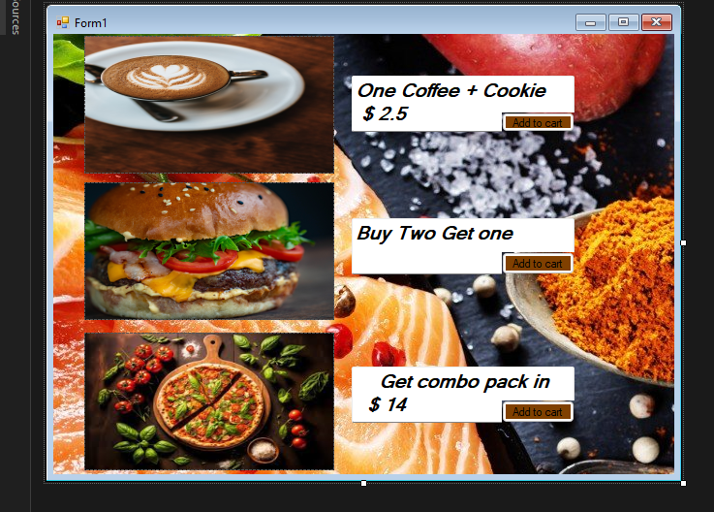

As an old member of this dialdeal sysytem I donot require to do regestraion process I can directly jump to the deals page and select on or more with cheap prices also can add reviews.

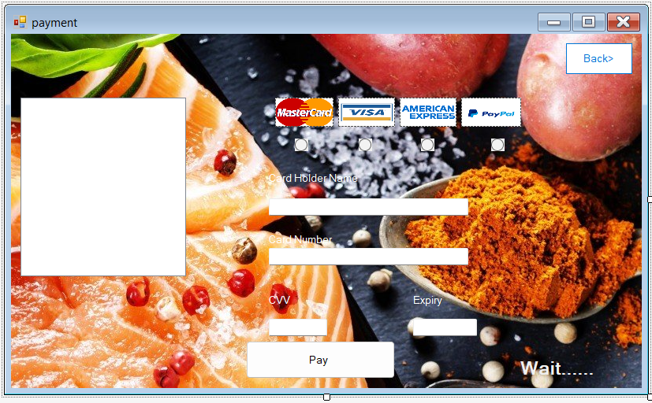

As buyer of the deals I have to make payments from this page to grab services of the deals.

**Group Member 1 name : Name of the user story**

**Abhishek sharma :**

**User story :- login and signup page for user (coding and designing )**

**Prabhkirat singh :-**

**User story :- homepage merchant login and signup (coding ,designing and linking**

**Abhishek choudary :-**

**designing and coding (payment page)**

**Lovepreet singh :-**

**designing and coding (deals and offer page)**

**Arshdeep singh :-**

**designing of orders cart ( merchant)**

Low-fidelity wireframe

<<Insert the image here>>

High-fidelity wireframe

<<Insert the image here>>

Feel free to add any other

designs you’ve developed e.g., prototypes

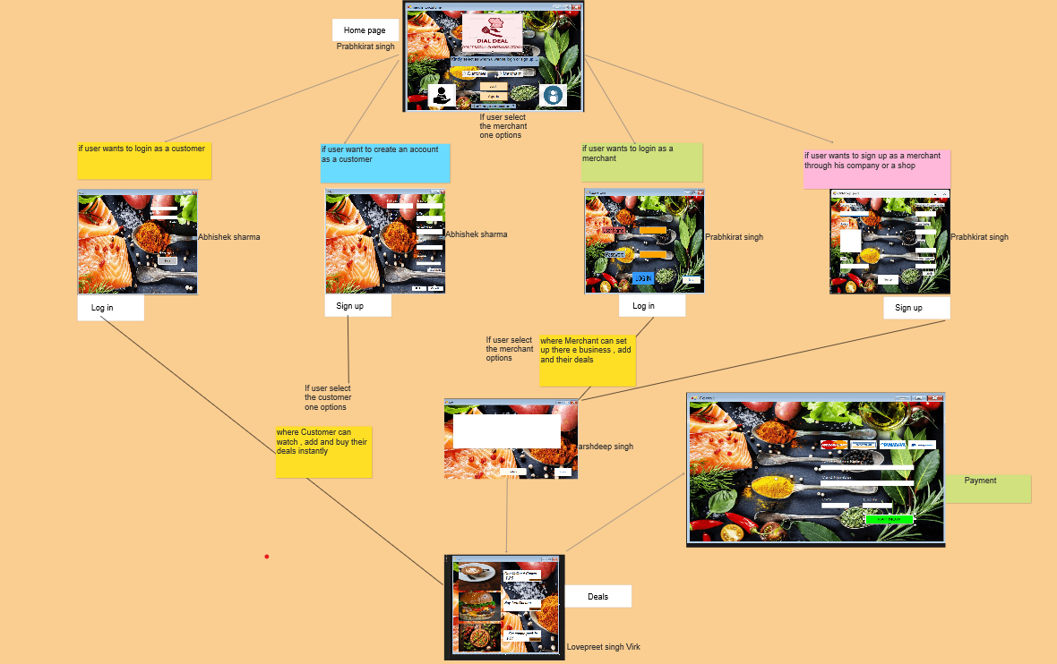

# Use of Agile

## Adapting AGILE in developing the project

Agile methodology is a collaborative and iterative approach to project management and software development that emphasizes flexibility, adaptability, and continuous improvement. When applied in a group setting, Agile promotes effective teamwork and empowers individuals to work together towards a common goal. Here's how Agile typically works in a group:

1. Cross-Functional Teams: Agile teams are usually composed of individuals with diverse skills and expertise relevant to the project. This ensures that the team can handle all aspects of the work and encourages collaboration across different disciplines.

2. Product Backlog: The team starts by creating a prioritized list of features, user stories, or tasks known as the product backlog. This backlog represents all the work that needs to be done throughout the project.

3. Sprint Planning: The team plans the work for a specific time frame called a sprint, which is typically two to four weeks long. During the sprint planning meeting, the team selects a set of items from the product backlog that they commit to completing during the sprint.

4. Daily Stand-up Meetings: The team holds brief daily meetings known as stand-ups to discuss progress, obstacles, and plans for the day. Each team member shares what they accomplished since the last meeting, what they plan to do next, and any challenges they are facing. The stand-up meetings promote transparency and help identify and resolve issues quickly.

5. Sprint Execution: The team works collaboratively to complete the tasks committed to during the sprint planning. They break down the selected items into smaller tasks, assign them to team members, and work on them iteratively. The team frequently reviews and adjusts their progress throughout the sprint.

6. Continuous Integration and Testing: Agile teams often adopt continuous integration practices, where code changes are regularly integrated into a shared repository. Automated testing is performed to ensure that the software remains functional and meets the defined requirements.

7. Sprint Review and Retrospective: At the end of each sprint, the team conducts a sprint review to demonstrate the completed work to stakeholders. This allows for feedback and facilitates continuous improvement. Additionally, the team holds a sprint retrospective to reflect on what went well, what could be improved, and to make any necessary adjustments for the next sprint.

8. Adaptation and Iteration: Agile teams embrace change and adapt their plans based on feedback and evolving requirements. They continuously refine and reprioritize the product backlog, allowing for flexibility in the project's scope and accommodating changing priorities.

By following these Agile practices, groups can collaborate effectively, respond to changes efficiently, and deliver high-quality products or projects in a collaborative and iterative manner.

## Managing the Trello board

### Daily Standups

Trello is a popular project management tool that can greatly facilitate collaboration and organization within a group project. Here's how Trello boards can help in a group project:

1. Task Management: Trello boards allow you to create lists and cards representing different tasks or project components. Within each card, you can add descriptions, checklists, due dates, and attachments. This helps the group organize and track individual tasks, assign responsibilities, and monitor progress.

2. Visualizing Workflow: Trello's board layout provides a visual representation of the project workflow. You can create columns to represent different stages or statuses, such as "To Do," "In Progress," and "Done." Each card can be moved across these columns as it progresses, giving everyone a clear overview of the project's current status and what tasks are in progress or completed.

3. Collaboration and Communication: Trello enables seamless collaboration among team members. Within each card, you can have discussions, ask questions, and provide updates using comments. This fosters real-time communication and eliminates the need for lengthy email threads. Team members can also mention others using @mentions to draw attention to specific tasks or discussions.

4. Assigning Responsibilities: Trello allows you to assign cards to specific team members, indicating who is responsible for each task. This helps in clarifying ownership and accountability within the group. Additionally, team members can use filters or labels to quickly see the tasks assigned to them, making it easier to prioritize their work.

5. Tracking Progress: As tasks are moved across the columns on the board, it becomes easy to track progress at a glance. The team can see what tasks are pending, in progress, or completed. Trello also provides progress indicators, such as checklists and due dates, allowing the group to assess how close they are to completing their goals.

6. Integration with Other Tools: Trello integrates with various third-party applications and services, such as Google Drive, Dropbox, and Slack. This allows the group to centralize project-related documents, share files, and receive notifications directly within Trello, enhancing efficiency and collaboration.

Overall, Trello boards provide a visual and intuitive platform for group project management, promoting transparency, collaboration, and task organization. It streamlines communication, enhances productivity, and helps teams stay focused on their shared objectives.

### Sprint planning and Sprint Review meetings

Here you can briefly explain how you conducted the above meetings and what you did there as a team. You can add screen shots for your product backlog and sprint backlogs you have.

All of group members was very excited to work together on this project and the introduction to Trello help to handle the tasks to create the systems that also directed by agile methodology and teams is the important platform for communication . all the sprints were done individually with high priorities trello link is give below .

# TrelloLink <https://trello.com/invite/b/6WzbQL8i/ATTI180457b9ed977150c8910a51ca752d4308CCED66/project-management>

# Version Controlling

Write a brief description of your reflections on using Github for version controlling – was it easy to set it up, what did you experience etc. Again one or two paragraphs would be sufficient.

Git hub is very effective tool to know about professional projects and sharing them to team members . like our team used this git hub to share imformations about our project later on we will explore more about gihub features and figure out how much it will be usefull to IT world

Add a link to your Github repository and make it public.

https://github.com/abhishek-2110/DialDealSystems.git

# Contributions

**Group Member 1 name : Name of the user story**

**Abhishek Sharma :**

**User story :- login and signup page for user (coding and designing )**

**Prabhkirat Singh :-**

**User story :- homepage merchant login and signup (coding ,designing and linking**

**Abhishek Choudary :-**

**designing and coding (payment page)**

**Lovepreet Singh :-**

**designing and coding (deals and offer page)**

**Arshdeep Singh :-**

**designing of orders cart ( merchant)**

# Reference

There are so many business but this project is bit different still we had some ideas from websites like ubereats.com and Zomato.in there will be more but all of them never give option of uploading deal by person who wants to promote his or her business , that is why this concept is different

We made a plan to build it up